Project Initiation
- Purpose of the initiation phase
- Comparing project options
- Total cost of ownership
- The project charter

The Initiation Phase
- Business problem or opportunity defined
- Solution is defined
- Project is formed
- Business case created
- Project team appointed

The Business Case
- Problem or opportunity: Detailed description
  - Introduction
  - Problem/opportunity statement
  - Assumptions and Constraints
  - Alignment with organizational objectives
- Solutions
- List of alternative analysis of benefits, costs, and issues
- Description of the preferred solution
- Main project Requirements
- Potential risks
- Summarized plan for implementation
  - Schedule
  - Financial analysis

Financial Considerations
Can compare projects based on
- Net present value
- Internal Rate of Return (Return on Investment or ROI)
- Payback Analysis

Net Present Value Analysis
- Considers the time value of money
- Costs for future years must be discounted to the present time
- Tangible benefits also discounted to the present time
- Must identify an appropriate discount rate
  - Take risk into consideration

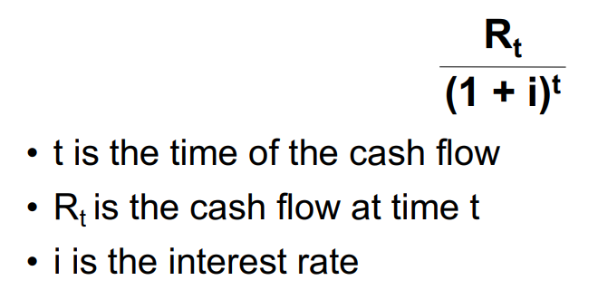
NPV Calculation

- Apply the above formula to each annual inflow and outflow of cash
- Add all terms together to get the NPV

NPV Analysis
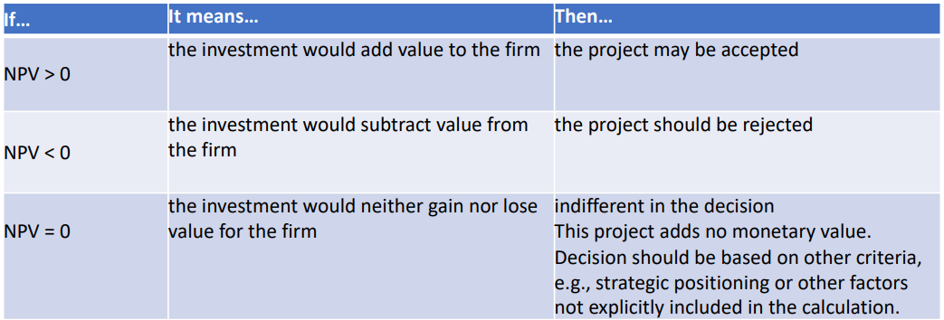

Rate of Return
(Total benefits – Total costs) / Total costs
- Can be used to compare different options
- Organizations may have a minimum acceptable rate of return for projects

Payback Analysis
- Compares cumulative costs to cumulative benefits
- Easiest to see in graphical format
- Time on a horizontal axis, money on vertical

The Project Charter
Purpose of the Project Charter
When signed off, you have approval to proceed to detailed planning, followed by carrying out your project.

Organizational Process Assets
- Is there a standard format for project charters?
- Is there a standard process for developing and getting approval for a project charter?
- What can the PMO do for you? What does the PMO require of you?
- Are there applicable “lessons learned” available from other projects?
- If you are inexperienced, is there a mentor available?
- Etc.

Project Charter – Typical Contents
- Identification section
- Project purpose or justification
- Measurable project objectives and related success criteria
- High-level requirements
- Assumptions and constraints
- High-level project description and boundaries
- High-level risks
- Summary milestone schedule
- Summary budget
- Stakeholder list
- Approvals

Identification
- Name of the project—make it meaningful
- Name, title, and department of a project sponsor
- Name of project manager
Clear Objective
SMART
- Specific
- Measurable
- Acceptable
- Realistic
- Time-based

Business Need or Opportunity
A concise statement of how the project’s deliverables will contribute to organizational objectives

Scope
Clearly defines what is in and out of the project

Major Milestones
- Identifiable points in time
- Target dates will be added LATER

Major Deliverables
Break down the overall objective into smaller measurable units

Assumptions
Things you are not certain of but can proceed if you behave as if they are true

Constraints
Anything that limits your ability to deliver or the range of acceptable solutions

Preliminary Cost Estimates
How will the costs be defined and controlled

Risks
- High-level statement about risks identified so far
- Include the risk of NOT doing the project

Stakeholder List
The stakeholders identified so far, including their roles

Approval
A place for the project sponsor and the project manager to sign

Project Initiation: Summary
- The first phase
- The relationship of the project to business objectives is key
- Compare alternatives using a weighted matrix
- Financial analysis: NPV, ROI, payback
- Project Charter is the primary output;
  - It includes the stakeholder list
- Completion of Project Initiation is the signal that the project has the approval to proceed to the project planning phase.

